TRAINING PROJECT REPORT

## Summer Training

**Reliance Industries LTD**

**(2023)**

## Project Topic

**“Employee Management System”**

Submitted By

**Priyanka Yashwant Jathar**

**Government Polytechnic, pen**

Guided By

**Mr. Kantimahanti Sivananda Kumar**

Datacentre IT Operations

Reliance Industries Limited

**RELIANCE INDUSTRIES LIMITED**

Patalganga

 Date:

**CERTIFICATE**

This is to certify that Ms.Jathar Priyanka,

has successfully completed her summer training

At Reliance Industries Limited, Patalganga in the partial fulfilment of the Diploma in Computer Technology, is a bonafied record of project work carried out by her under my supervision.

Mr. K S Kumar Mr. Sanjay Shukla

Mentor HOD - IT

Datacentre Operations

**ACKNOWLEDGEMENT**

I extend my gratitude to Reliance Industries Limited, Patalganga for providing me the opportunity to learn through the Summer Internship and successfully completing my training.

I take immense pleasure in thanking **Mr. Gopal Bhagat**, HR Learning Dept. for giving me an opportunity to pursue an internship at RIL-PG.

I express my deep gratitude to **Mr. K S Kumar**, Manager IT Operation who has without any hesitation permitted us to undertake the Work Report in Overview of IT System Overview His dedication and keen interest above all his overwhelming attitude to help his student had been solely and mainly responsible for completing my work.

I also thank to **Mr. Sanjay Shukla**, HOD-IT Dept. for extending his immense support and attention throughout my internship training.

My special thanks to **Mrs Sayali Aambavane**, Head of Department, Computer Technology for his kind help and cooperation throughout the project.

Last but not the least, I express my profound gratitude to those who helped me directly or indirectly in my endeavour and infused their help for success of this summer training.

## CONTENT

|  |  |  |
| --- | --- | --- |
| **CHAPTER** | **TITLE** | **PAGE** |
| CHAPTER 1 | INTRODUCTION TO THE COMPANY | 5 |
| CHAPTER 2 | SAFTY TRANNING   * Safety Equipment * Zero Tolerance | 7 |
| CHAPTER 3 | INFORMATION OF HARDWARE COMPONENT OF COMPUTER | 8 |
| CHAPTER 4 | INSTALLATION OF WINDOWS 2019 SERVER | 9 |
| CHAPTER 5 | INTRODUCTION TO DATABASE | 18 |
| CHAPTER 6 | PROJECT |  |
| CHAPTER 7 | AUTOMATED PRODUCT HANDLING SYSTEM |  |
|  | CONCLUSION | 29 |
|  | REFERENCES | 30 |

**CHAPTER 1**

### COMPANY INTRODUCTION

The Reliance Industries Limited (RIL)-Patalganga Manufacturing Division (PMD) started its operation in 1983 before the Environment Impact Assessment notification came into existence. Hence, there is no Environment Clearance available for this project.

The Reliance Group, founded by Dhirubhai H. Ambani (1932-2002),

Is India's largest private sector enterprise, with businesses in the energy and

Materials value chain. Group's annual revenues are in excess of US$ 58 billion.

The flagship company, [Reliance Industries Limited](http://www.ril.com/), is a Fortune Global 500

Company and is the largest private sector company in India. Reliance enjoys

Global leadership in its businesses, being the largest polyester yarn

and Fibre producer in the world and among the top five to ten

producers in world in major petrochemical products.

### CHAPTER 2

**Introduction:**

A Safety Management System (SMS) is a systematic approach to managing safety, including the necessary organizational structures, accountabilities, policies and procedures. As per ICAO requirements, service providers are responsible for establishing an SMS, which is accepted and overseen by their State.

Reliance is committed to ensuring environmentally sustainable and responsible operations to achieve highest standards of excellence. Our manufacturing divisions have not only instituted internationally accepted Environmental Management System based on ISO-14001.

**Safety Equipments :**

* Safety shoes :

A steel-toe boot (also known as a safety boot, steel-capped boot or safety shoe) is a durable boot or shoe that has a protective reinforcement in the toe which protects the foot from falling objects or compression, usually combined with a mid-sole plate to protect against punctures from below.

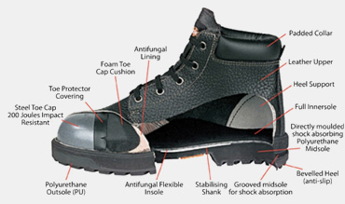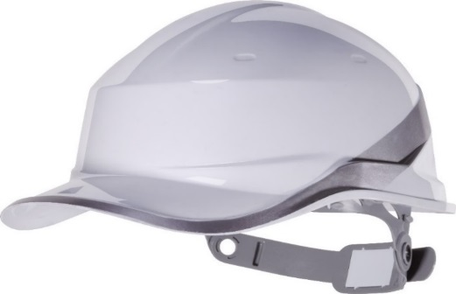

* Safety Helmets :

A hard hat is a type of helmet predominantly used in workplace environments such as industrial or construction sites to protect the head from injury due to falling objects, impact with other objects, debris, rain, and electric shock. Suspension bands inside the helmet spreads the helmet's weight and the force of any impact over the top of the head.

* Safety gloves :

Safety gloves are hand garments meant for the protection of the wrist, hand, fingers, and thumbs from adverse processes or conditions. These items are virtually limitless in application and find employment in both industrial and commercial marketplaces. Their functionality is determined by the material and design of the glove.

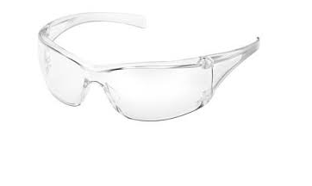

* Safety Googles :

Goggles or safetyglasses are forms of [protective eyewear](https://en.wikipedia.org/wiki/Eye_protection) that usually enclose or protect the area surrounding the eye in order to prevent particulates, water or [chemicals](https://en.wikipedia.org/wiki/Chemical) from striking the [eyes](https://en.wikipedia.org/wiki/Human_eye). They are used in [chemistry](https://en.wikipedia.org/wiki/Chemistry) laboratories and in [woodworking](https://en.wikipedia.org/wiki/Woodworking). They are often used in snow sports as well, and in [swimming](https://en.wikipedia.org/wiki/Swimming_(sport)). Goggles are often worn when using [power tools](https://en.wikipedia.org/wiki/Power_tool) such as [drills](https://en.wikipedia.org/wiki/Drill) or [chainsaws](https://en.wikipedia.org/wiki/Chainsaw) to prevent flying particles from damaging the eyes.

**Zero Tolerance :**

A zero**-tolerance** policy is one which imposes strict punishment for infractions of a stated rule, with the intention of eliminating undesirable conduct.

Zero-tolerance policies have been adopted in all around RIL Industries. These policies are usually promoted as preventing smoking, drinking and prohibiting mobile phones. Staff members, workers and other visitors, who possess a banned item or perform any prohibited action for any reason are automatically punished.

Zero Tolerance Rules :

1. No Smoking, No Drugs, No Alcohol, No Ignition sources.
2. No Violation of Work Permit Conditions.
3. No Line Break Without Authorization.
4. No Entering Confines Space Without Authorization.

### CHAPTER 3

**INFORMATION OF HARDWARE COMPONENT OF**

Computer hardware is a collective term used to describe any of the physical components of an analog or digital [computer](https://www.techtarget.com/searchwindowsserver/definition/computer). The term hardware distinguishes the tangible aspects of a computing device from [software](https://www.techtarget.com/searchapparchitecture/definition/software), which consists of written, machine-readable instructions or [programs](https://www.techtarget.com/searchsoftwarequality/definition/program) that tell physical components what to do and when to execute the instructions.

**MOTHERBOARD:-**

The motherboard serves as a single platform to connect all of the parts of a computer together. It connects the CPU, memory, hard drives, optical drives, video card, sound card, and other ports and expansion cards directly or via cables.

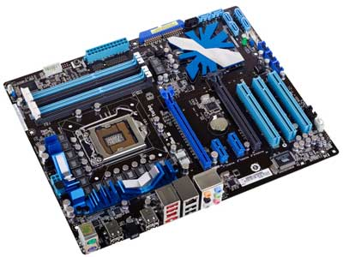

**RAM:-**

[**Computer RAM**](https://www.crucial.in/products/memory)  works closely with the CPU and temporarily stores information created by programs so that it's immediately accessible. It’s sometimes referred to as ‘volatile’ memory because this data gets erased every time your computer restarts.

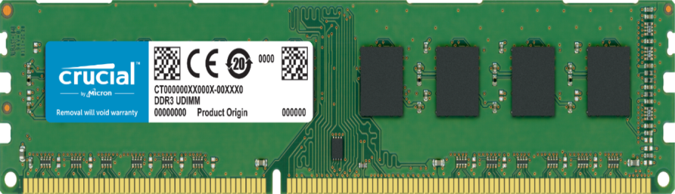

**CHAPTER 4**

**INSTALLATION OF WINDOWS SERVER 2019**

**HP ILO – Configuring Hardware RAID**

**INTRODUCTION**

RAID (Redundant array of Independent/Inexpensive Disk) is the optimum way of providing hard disk redundancy for your server against disk failure. Sometime one don’t want to install OS directly on single disk, instead system architects prefer OS to be spawned across numerous disks configured in RAID.

STEPS OF ACTION

Power ON the system and from ILO presses F10 to select INTELLIGENT PROVISIONING.

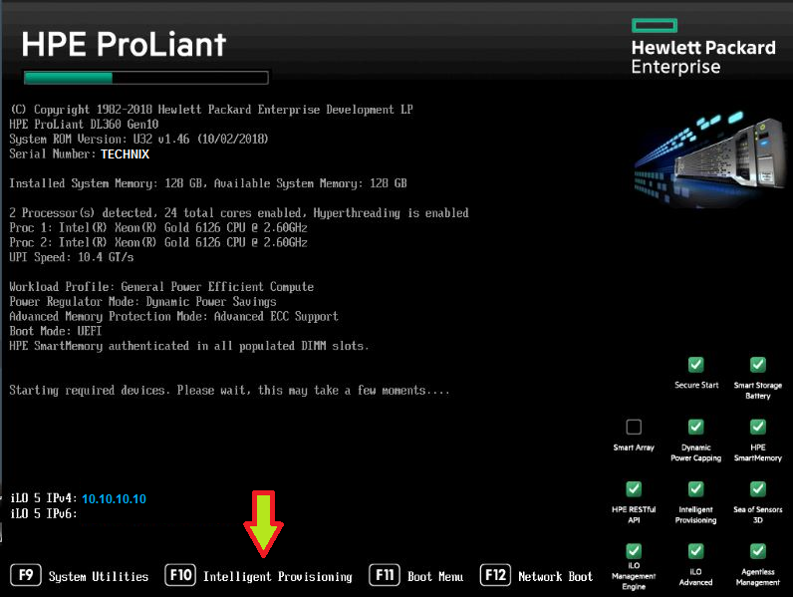

This will open a wizard where it will load the Intelligent provisioning.

### CHAPTER 5

**INTRODUCTION TO DATABASE MANAGEMENT SYSTEM**

* A database is a collection of inter-related data which helps in the insertion and deletion of data from the database and organizes the data in form of tables, views, reports, etc.
* The software which is used to manage the database is known as Database management system.
* The main aim of a DBMS is to supply a way to store up and retrieve database information that is both convenient and efficient.

**COMMANDS IN SQL:-**

1. **DDL COMMAND IN SQL**

DDL is an abbreviation of **Data Definition Language**.The DDL Commands in Structured Query Language is used to create and modify the schema of the database and its objects. The commands of Data Definition Language deal with how the data should exist in the database.

**CREATE COMMAND:-**

CREATE is a DDL command used to create databases, tables, triggers and other database objects.

**CREATE** **TABLE** table_name    (

column_Name1 data_type ( **size** **of** the **column** ) ,

...

column_NameN data_type ( **size** **of** the **column** )

) ;

**DROP COMMAND:-**

DROP is a DDL command used to delete/remove the database objects from the SQL database

Syntax: DROP TABLE Table_Name;

**ALTER COMMAND:-**

1. ADD

Alter Table Table_Name

ADD (Column1 Datatype,

Column2 Datatype,

ColumnN Datatype );

1. Truncate command

Truncate Table Table_name;

1. Alter Table Table_Name

Rename oldname To newname;

1. **DML COMMAND IN SQL**

The DML commands in Structured Query Language change the data present in

The SQL database. We can easily access, store, modify, update and delete the

existing records from the database using DML commands.

**INSERT**

Insert command is used to insert data into a table.

Syntax:Insert into <table_name> (column list) values (column values);

**DELETE**

Delete command is used to delete records from a database table.

Syntax:Delete from <table_name>WHERE condition;

**UPDATE**

Update command is used to update existing data within a table.

Syntax:UPDATE <table_name> SET column_name Where(condition);

**NORMALIZATION**

* Normalization is the process of organizing the data in the database.
* Normalization is used to minimize the redundancy from a relation or set of relations. It is also used to eliminate undesirable characteristics like Insertion,Update, and Deletion Anomalies.
* Normalization divides the larger table into smaller and links them using relationships.
* The normal form is used to reduce redundancy from the database table.

**Data modification anomalies can be categorized into three types:**

* Insertion Anomaly: Insertion Anomaly refers to when one cannot insert a new tuple into a relationship due to lack of data.
* Deletion Anomaly: The delete anomaly refers to the situation where the

deletion of data results in the unintended loss of some other important data.

* Updatation Anomaly: The update anomaly is when an update of a single data value requires multiple rows of data to be updated.

Types of Normal Forms:

|  |  |
| --- | --- |
| **Normal Form** | **Description** |
| [1NF](https://www.javatpoint.com/dbms-first-normal-form) | A relation is in 1NF if it contains an atomic value. |
| [2NF](https://www.javatpoint.com/dbms-second-normal-form) | A relation will be in 2NF if it is in 1NF and all non-key attributes are fully functional dependent on the primary key. |
| [3NF](https://www.javatpoint.com/dbms-third-normal-form) | A relation will be in 3NF if it is in 2NF and no transition dependency exists. |
| BCNF | A stronger definition of 3NF is known as Boyce Codd's normal form. |

**BACKUP**

A **backup** is a copy of the data that store in the cloud. Backing-up is an important process that everyone should do to have a fail-safe for when the inevitable happens. The principle is to make copies of particular data to use those copies for restoring the information if a failure occurs. A data loss event occurs due to deletion, corruption, theft, viruses, etc.

### Full backups

The most basic and complete type of backup operation is a full backup. As the name implies, this backup type makes a copy of all data to a storage device, such as a disk or tape. The primary advantage of performing a full backup during every operation is that a complete copy of all data is available with a single media set.

### Incremental backups

An incremental backup operation will result in copying only the data that has changed since the last backup operation of any type. An organization typically uses the modified timestamp on files and compares them to the last backup timestamp.

### Differential backups

A differential backup operation is similar to an incremental the first time it is performed, in that it will copy all data changed from the previous backup. However, each time it is run afterward, it will continue to copy all data changed since the previous full backup. Therefore, it will store more backed up data than an incremental on subsequent operations, although typically far less than a full backup.

**CHAPTER 6**

**Project outcomes:**

## CHAPTER 7

**Automated Product Handling System**

**Introduction to APHS :**

More than 120 automation systems installed world wide, Salmoiraghi may certainly be considered as the absolute market leader.

Our Automated Handling System featuring high efficiency and excellent cost performance ratio incorporate highly innovative solutions developed along the years (many of which are protected by international patents).

We offer a wide range of field-proven solutions for handling and computerized tracking of yarn bobbins all the way from the winding machines to packings.

**Overview of APHS :**

The end product POY (Partially Oriented Yarn) from the manufacturing division is winded on a single unit called as a Bobbin, at the rate of 3000 frequency. On each Doff (bobbins carrying unit) eight bobbins are assembled using automated shuttle. The shuttle has a scanning machine that scan the barcode of each Doff and assembles accordingly.

For Example

Barcode---- 0 43 065 2 3 81

Machine No Bobbin No. Checksum

Position No. Doff No.

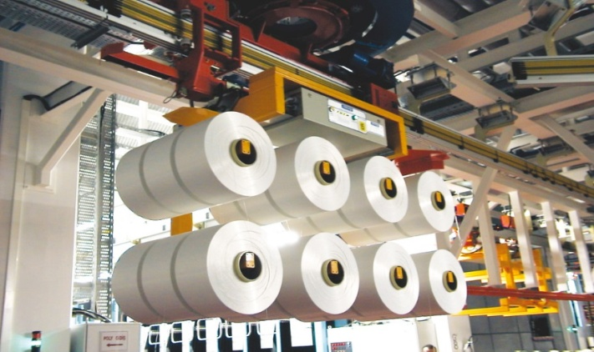

This Doff travels through three major station :

* 1. Physical Testing Station :

Test performed are as follows :

* Cross Section
* Denier
* Draw Tension
* TenasityAlongation
* Entanglement
  1. Pre-visual Inspection Station :

Mirrors are installed on the both ends of doff through which all sides of bobbins are examined by the examiner and faults are identified.

* 1. Visual Inspection Stations :

Final weight and grade of the bobbins are determined and accordingly bobbins are accepted or rejected.

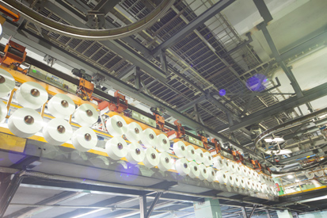

The storage area of bobbins is called as CAROUSELS. It has 9 Bobbin Storage Towers with the capacity of 27000 bobbins. Each tower has 3 layers- UPPER, MIDDLE, LOWER.

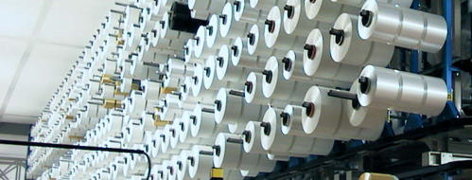

SALMOIRAGHI LOADER loads bobbins from the Doff to the assigned towers.

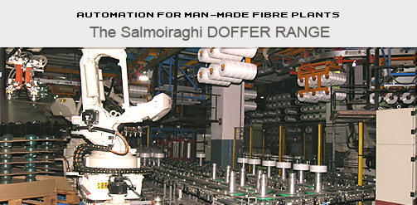

As per the order by the particular agency, the bobbins are unloaded by the Salmoiraghi Unloader.

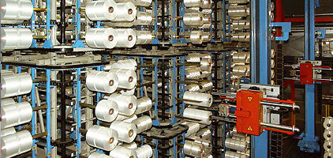

As per the company’s requirements, Salmoiraghi system is programmed to pack the bobbins in the order of 3*3 or 4*4 manner.

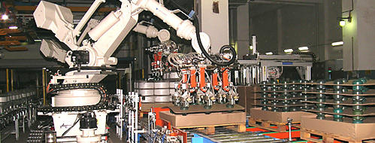

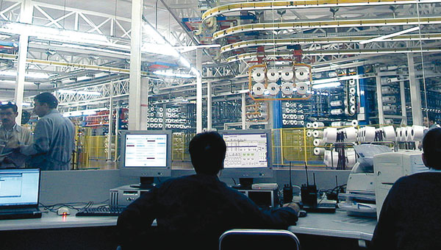

These Packed bobbins are then transported to the Dispatch Department.

## CONCLUSION

I come to know what is actually happening in such a large

Industries & how they overcome their problems & difficulties. I, hereby conclude that JSW Steel Limited through being a steel maker has given me information of a how they use the technology in SMS plant.

We also studied that teamwork is very essential for a success of such companies. My journey in JSW Steel Limited will become a valuable experience which will definitely help me in my future career.

## REFERENCES

* [www.ril.in](http://www.ril.in)
* [www.google.com](http://www.google.com/)

## CERTIFICATE

This is to certify that **Miss. Nilam Dilip Mhatre**regular Trainee of Diploma has successfully completed One Month Internship “**Training on use of Technology in a SMS Plant**” fulfilment of the training to **JSW Steel Ltd, Dolvi works**.

This research has been conducted under supervision & guidance of **Mr. Anil Pawar.** To the best of knowledge, all the reference & various source obtained in preparing this report has been duly acknowledging.

Mr. ………………... Mr. Anil Pawar

---------, training dept. ----------------------------